- \Operation\Basic settings\Speed
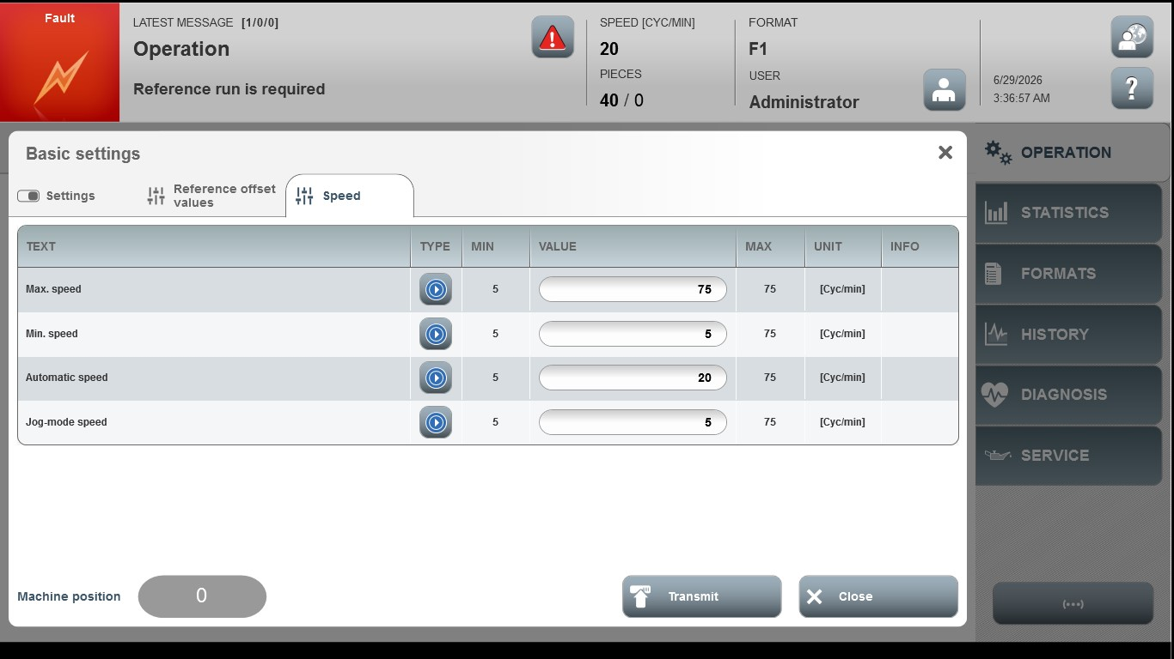
Acceptance criterion | Limits | Pass / Fail: Dev-No. | Date | Initials
Screen matches screenshot | N / A
Max. speed | 5 … 75
Min. speed | 5 … 75
Automatic speed | 5 … 75
Jog-mode speed | 5 … 75

